To Whom It May Concern:

My name is Kathryn Blizzard and I am the Director of Skate for Wishes.

What began as a service project through the Ocean City High School Interact Club has grown to become an annual event attended by hundreds of families from around South Jersey to grant the wish of a New Jersey child at the end of the holiday season.

For the past nine years, Skate for Wishes has been granting wishes for kids suffering with life-threatening medical conditions through the Make-A-Wish® Foundation of New Jersey. Each year on New Years Eve, families and friends come together to skate at the Flyers Skate Zone in Atlantic City and make wishes come true. This past year, over 250 skaters took to the ice; in turn, they raised awareness and over $2,300 to grant the wish of a local child suffering with a life threatening medical condition!

Skate for Wishes would not be what it is today without the help of local sponsors who help us keep our event operating with a $0 budget. At this time, Skate for Wishes graciously welcomes you to become a partner in our mission. We are seeking both event sponsors as well as businesses to provide in-kind donations to be used during our event’s raffle. In return, your company will be promoted through all of our social media platforms as well as throughout the skating event.

Please feel free to visit our website SkateforWishes.org and contact me with any questions that you may have.

Event Details
Proceeds Benefitting: The Make-A-Wish® Foundation of New Jersey
Event Date: December 31st, 2016 10am-4pm
Location: Atlantic City Flyers Skate Zone
Attendance: 250+

Thank you for taking the time to review this request and please do not hesitate to contact me with any questions.

Have a wonderful day!
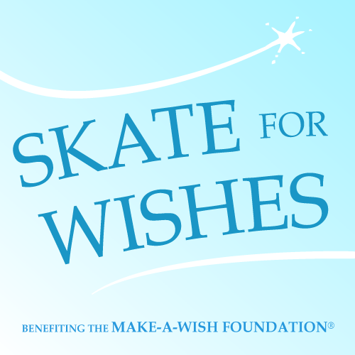

Katee Blizzard
Skate for Wishes Director
skateforwishes@yahoo.com
Cell Phone: (609)502-2174

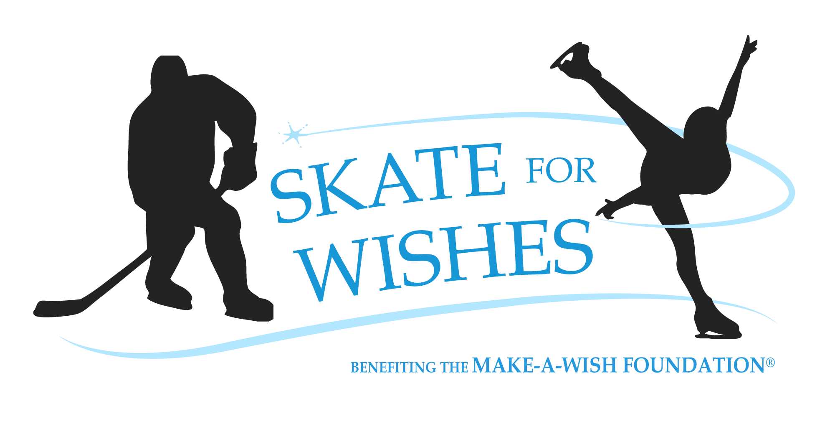
EVENT SPONSORSHIP OPPORTUNITIES
**All sponsorship and merchandise sales, go directly towards benefiting
The Make-A-Wish® Foundation of New Jersey**

At this time, Skate for Wishes graciously welcomes businesses both local and national to become partners in our mission. Both monetary and in-kind donations are greatly appreciated and help us in granting wishes for local children suffering with life-threatening medical conditions. Visit skateforwishes.weebly.com/sponsors to view past sponsors

Event Sponsor: $1,000
Largest Logo on Website
3 Social Media Shout Outs
Logo on all Marketing Materials
Sponsorship Table at Event
Gold Level Sponsor: $500+
Multiple On-Ice Shout Outs
Large Logo on Website
2 Social Media Shout Outs
Sponsorship Table at Event
Silver Level Sponsor: $100+
Small Logo on Website
1 Social Media Shout Out
Small Logo at Registration Table
Bronze Level Sponsor: $50+
Bronze Sponsors receive personal thank you card from Skate for Wishes

Name/Company:_______________________________________________________________
Sponsorship Level:_____________________________________________________________
Phone:____________________________________
Address:_____________________________________________________________________
Email:___________________________________________________________
Additional Request: ____________________________________________________________

